ePortfolio Testing

Program: SCIE3050

Topic | Instructions | Correct?
General instructions
Help | - Please work through the below steps to check your ePortfolio has been set up correctly.  - If you need help with the testing please log a job with help@learn.uq.edu.au with subject line ELSS – ePortfolio testing  - Please take note of any issues and log a job with help@learn.uq.edu.au with subject line ELSS – ePortfolio if you need help resolving them.
Test accounts
Student | - Set up two dummy student test accounts to use for testing using the external user’s tool. They should have the surname Science so they are easily identified as dummy test accounts. • https://elearning.uq.edu.au/guides/enrol-users/external-users-tool • Remember to enrol the dummy student test accounts will need be enrolled in all courses that you need to test. Follow this guide but select the role of student: https://elearning.uq.edu.au/guides/enrol-users/enrol-teaching-andadministration-staff
Course Coordinator | - If you need additional staff to have course coordinator accounts follow the guide:  https://www.elearning.uq.edu.au/content/create-eportfolio-course-staff-accounts
External assessors | - The following school staff have been set up with test external assessor accounts: Melissa Fitzgerald, Amanda Cooke, Susan Rowland, Louise Kuchel  - Name format: First Last – External i.e. Mary Smith – External  - Email address (Eduroam format): username@uq.edu.au i.e. uqmsmith@uq.edu.au  - If you need additional staff to have test external assessor accounts follow the above formatting rules (DO NOT use standard UQ email addresses as they will be needed for assessor / course coordinator accounts) and the guide:  https://www.elearning.uq.edu.au/content/create-eportfolio-course-staff-accounts
Checking Learn.UQ (Blackboard) links
Access | - Log into Learn.UQ (Blackboard).  - Navigate to your course.  - Navigate to the Assessment folder (if you have moved your ePortfolio links please navigate to that location).
ePortfolio links | - Check the following:  - Link titles match those in your ECP  - Click on the down arrow next to Link heading and select Edit.  - Ensure enable evaluation is set to Yes if you require a mark to be sent back to Grade Centre.  - Confirm points possible is set to desired number.  - If you are using a Grading Schema in Grade Centre to show the result with a text descriptor instead of a mark the point possible should be set to 100.  - Choose if you wish the Grade Centre column to be visible to students. (Yes = students can see results in my grades, No = results hidden from students. This setting does not control release of results in the ePortfolio).  - Click submit to save changes.
Task Instructions | - Update the task instructions:  - Click on the down arrow next to the task instructions and select Edit.  - Add any task specific instructions  - DO NOT modify the Technical instructions and support details, if you think these need to be changed please let us know.  - Click submit to save changes.
Checking Table of Contents (TOC)
Access | - Click on any ePortfolio link in your course.  - Navigate to: Menu > Curriculum > Table of Contents  - Left click on the required TOC and select Edit
General check | - Check the following:  - Correct Program / Major name  - Correct course codes (no course titles)  - Correct assessment names  (same as ECP and similar tasks named consistently across all courses)  - Correct outcome names (if relevant) – outcome may be professional standards, competencies, learning objects, graduate attributes etc  Guide: Add and Edit Sections and Sub-Sections in Table of Contents
Settings | - Click on the Settings tab (above the TOC menu).  - Check the settings.  Guide: Edit Table of Contents settings
For each assessment task
Frames | - Click on the Edit Frame button.  - Check / edit the text  Heading: Include very brief submission instructions. Uncheck Include in Portfolio.  Question: Instructions available in Blackboard / the ECP should not be repeated here. Include a simple one sentence description of the task.  Instructions: These are displayed in a drop down box. Generally the instructions are stored in Blackboard not the ePortfolio.  Guide: Add or edit Frames in a Table of Contents
Form (if relevant) | - Click on the form link and check:  - Correct question text and relevant hint text (highlighted yellow).  - Correct type of field i.e. Multiple or single line textbox.  - Required fields i.e. Students must enter content into these fields before they can submit the work for marking.  - Take note of the form name if it needs editing.  Guide: Edit form builder
Assessment instruments (rubrics) | - Click on the Instrument links tab  - Note the name of the Assessment instrument.  - Click on the Settings icon.  - Check what is being submitted: Single page / Page and subpages / Whole Portfolio.  - If there is a supplementary Assessment instrument note its name.  - It is not recommended to use the Maximum submissions as it can create issues if students repeat the course.  - It is also not recommended to use Due date / Cut Off date as you need to remember to change them every time a course is run.
Content Requirements | - Click on the Content Requirements tab.  - Note, students will not be able to submit work unless the Content Requirements are met.  Guide: Add and edit Content Requirements
Checking Assessment instruments (rubrics)
Access | - Navigate to: Menu > Curriculum > Assessment Instruments
Outcome mapping  (if relevant) | - Left click relevant assessment instrument and select View Linkages  - Check the links to outcomes (outcomes may be professional standards, competencies, learning objects, graduate attributes etc)
Assessment Instrument  rubric | - Left click relevant assessment instrument and select Edit and check:  - Criteria titles  - Performance level titles  - Descriptors  - Marks  Guide: Create Assessment instrument
Assessment instrument  Settings  Release results | - Select the Settings tab  - At the bottom of the page check:  - The correct school has been selected.  - If you want to release the student results all at the same time check the below settings have been selected:  - Decide if you want to unable assessor to change individual student release options i.e. If the rest of the cohort’s results have been released already and a tutor is marking a later submission.  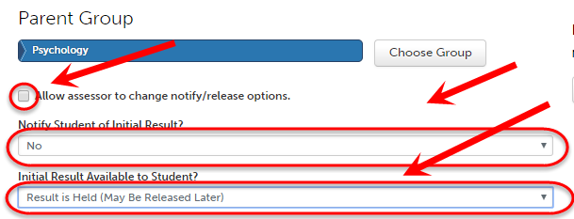
Text descriptors  (if relevant) | - If you want to display a drop down list of descriptors instead of a rubric check the appropriate peg map has been selected.  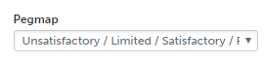
Assessor | - Check the correct assessor selection method has been selected.  - Candidate Chooses Assessor: Student enters the name of the UQ marker i.e. Their tutor  - Work is Submitted to Assessor Pool: Work will automatically be sent to either one person (usually course coordinator) or randomly allocated to someone in the pool (i.e. a tutor).  Note the name of the Assessor Pool to later check the staff/s members in it.  - Candidate Specifies External Assessor: Student will enter the name of a non UQ marker (previously uploaded by staff) i.e. prac supervisor, preceptor  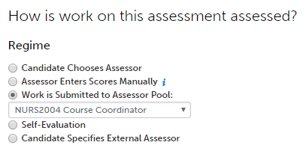
Checking outcome sets
(outcomes may be professional standards, competencies, learning objects, graduate attributes etc)
Outcome Set | - Navigate to Menu > Curriculum > Outcome Sets  - Left click relevant Outcome Set and select View and check:  - Formatting and wording  - Links to Assessment Instruments
Checking student submission
Enrol test students | - Enrol the test students in all relevant program courses.  - You will need to make your course available temporarily so the test students can access your course. See this guide to make course available https://www.elearning.uq.edu.au/content/make-course-available  - Follow the steps in the below guide using the test student username at the start of the document and selecting the role of Student.  Guide: Enrol teaching and administration staff
Log in as a student | - Log into Blackboard using a test student account.  - Log out of Blackboard using your own account by clicking on the logout icon.  - Click on the here link  - Use the test student account details at the start of this document.
Submit assessment | - For all courses in the program submit all ePortfolio assessment items.  - Follow the relevant student instructions and use the instructional videos if needed.  - Submit the assessment to yourself (either your course coordinator or external assessor account).
Send External assessment
Send External assessment | - Assessment instrument: SCIE3050 Placement Supervisor Report and SCIE3050 Placement Supervisor Report (with attached Presentation)  - Test sending assessment to external assessors use the items named above and your test student and external assessor accounts.  Video: Send external assessment
Checking marking student work
UQ assessor | - Log into Blackboard and click on an ePortfolio link in any course.  - Mark all assessment.  Guide: Assess student submissions  Note: If the results are returned to the Grade Centre you need to save twice.  The first Save is to the ePortfolio and  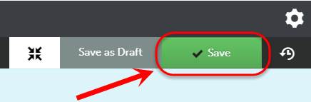  the second Save is to return the result to the Blackboard Grade Centre.  The Grade Centre column must be selected from the FOR LMS ASSIGNMENT drop down menu.  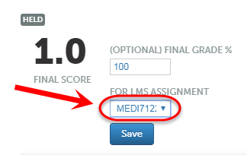
UQ assessor  2 rubrics  (optional) | Note: If you have an additional supplementary assessment instrument (rubric), though they will show in your appending assessment list individually they will be displayed on the same page for marking.  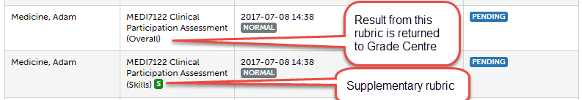  In panel view the rubrics show in different tabs.  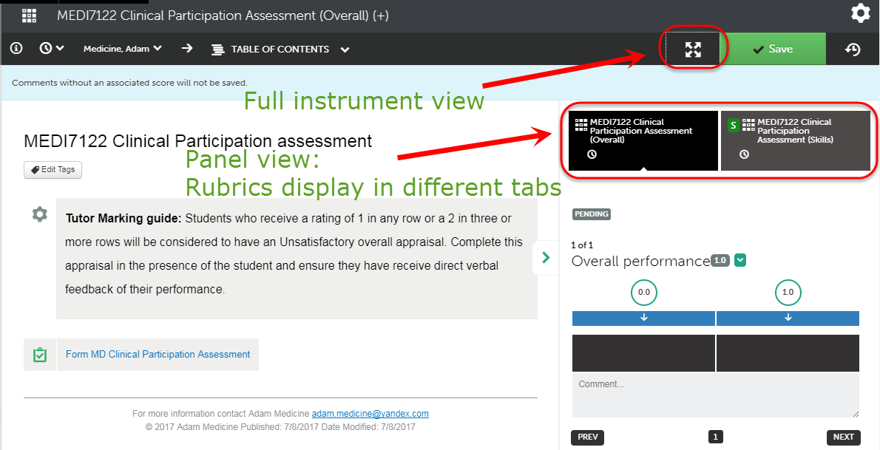  In full instrument view the rubrics show on the same page  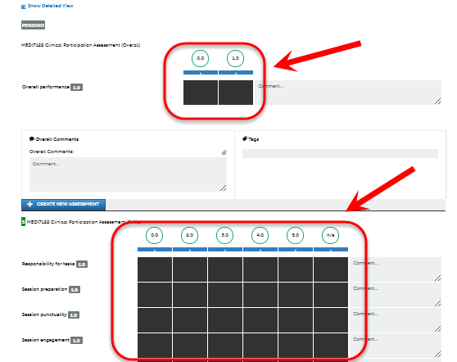
External assessor | - Log into your UQ email and you should have emails from Chalk and wire.  - Remember to enter your test external assessor email when prompted i.e. username@uq.edu.au  Guide: Quickstart Guide for External Assessor
Release HELD results | - If you have held results (i.e. this was an assessment instrument setting) you will need to release the results to finalise the testing.  Guide: Release held student results
Check student results (UQ staff)
Grade Centre | - Check the correct results have been transferred to Grade Centre.  - If a Grading Schema has been used check the text descriptor is correct.
Student cohort outcome set report
(outcomes may be professional standards, competencies, learning objects, graduate attributes etc)
Check student results (Student view)
Check results (student) | - Log into Blackboard using a test student account. (see previous instructions)  - Navigate to the required ePortfolio assessment link.  - Check there is a link in the technical instructions to the video ePortfolio Viewing Results.  - Follow the video instructions.  - Video: ePortfolio Viewing Results
Student outcome set report  (outcomes may be professional standards, competencies, learning objects, graduate attributes etc) | - Log into Blackboard using a test student account. (see previous instructions)  - Navigate to any ePortfolio link.  - Check there is a link in the technical instructions to the video ePortfolio Outcomes Report.  - Follow the video instructions.  Video: ePortfolio Outcomes Report
Delete test student assessments
Access | - Navigate to Menu > Assessment > Student Results.
Delete a submission | - Use the search function to find your test student submissions.  - Left click on submission and select Delete from the menu.  - Click Delete button to confirm the deletion.  - Repeat until all test student submissions have been deleted.
Make course unavailable | - Once student testing is complete you can make your course unavailable again by following this guide: https://www.elearning.uq.edu.au/content/make-course-available
Prepared by: [Ailsa Dickie]
Last modified: [26 August 2019]

