Student ePortfolio workshop – PHRM1012

Topic | Content
Preparation |  | - Set up two dummy student test accounts to use for testing using the external users tool. They should have the surname Pharmacy so they are easily identified as dummy test accounts.  - https://elearning.uq.edu.au/guides/enrol-users/external-users-tool  - Remember to enrol the dummy student test accounts will need be enrolled in all courses that you need to test. Follow this guide but select the role of student: https://elearning.uq.edu.au/guides/enrol-users/enrol-teaching-and-administration-staff
Login |  | - Login into course as the Test student.  - Use the nk link to login as the test student.  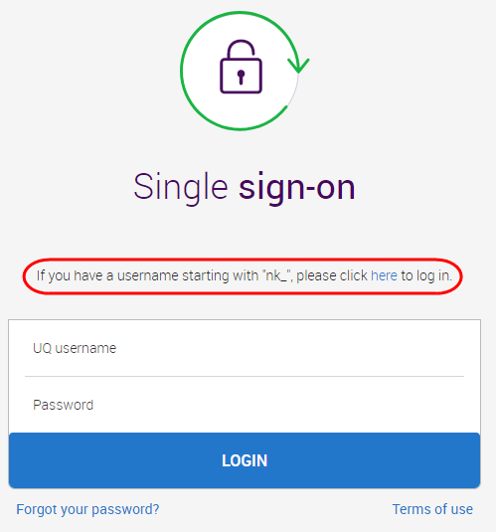
General information about the ePortfolio system
Why are you using the ePortfolio system |  |  | - It is a record of your learning and reflection through your program.  - Over you degree this gives you an opportunity to demonstrate personal and professional growth.  - This is your own space your course coordinators don’t have access unless you submit work.  - You can export your work that you can put together as part of your CV, link to your LinkedIn and send to potential future employers.  - After graduation, you have access for up to 4 years (read only) after that for full access you can go into an agreement with the vendor for approx. $US100 for 5 years.
Access |  |  | - You need to ensure you click on the links through your Blackboard course to access the ePortfolio system so grades will be transferred back to the grade centre.  - There are resources in your Blackboard course on how to submit for each assessment piece including AskUs support.  - The first time students use the ePortfolio they will need to accept a user agreement.

Assessment: Reflective Task and Evidence of Skills
Upload a file | - Read instructions provided by course coordinator in your assessment folder.  - You will have to accept the user agreement the first time you log into the system.  - Access the Reflective Task and Evidence of Skills assessment link through your Blackboard site.  - Pay attention to the page requirements.  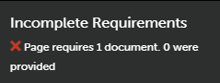  - Click on the ADD CONTENT drop down Add File  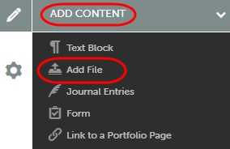  - Click on Insert Content Here.  - Attach files through:  - Drag and drop  - Add files  - Dropbox or  - OneDrive  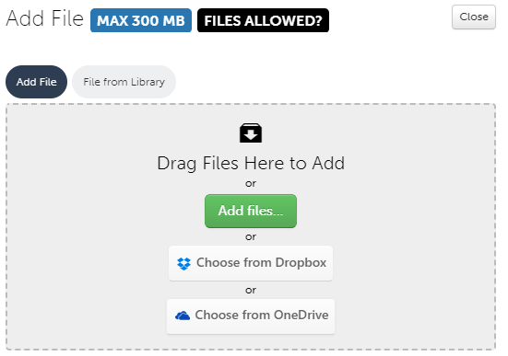  - Click on the Start Upload (or Start Uploading All for multiple files) button.  - Click on the Close button.  - Click on the Submit button.  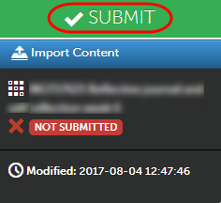  - Confirm submission by clicking the Submit button.
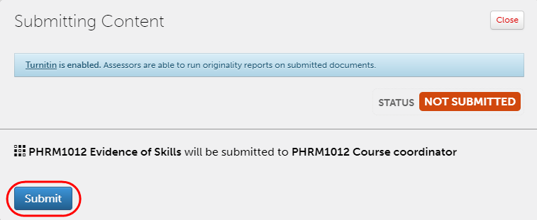
- Confirm your submission by checking the right hand side panel.
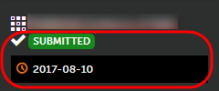
Editing and Deleting your work | - When editing / deleting or withdrawing work remember that staff cannot see your updates unless you resubmit your work.  - Click on the wheel icon to EDIT or DELETE your work.  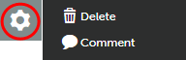
Withdrawing your work | - Staff cannot see changes you have made unless you withdraw and resubmit your work.  - Click on the date stamp below the submitted button.  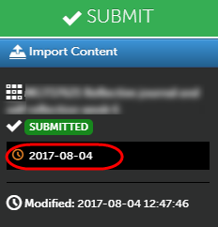  - Click on the Withdraw button.
Assessment 2 | - Assessment item Attendance Sheet will be a file upload – this will be the same process as above.
Activity | - Students to Add a File to Project Outline.  - All student are to withdraw their work.
Access results and feedback
Accessing results | 3 ways to view your results.  1. On the assessment submission page.  - Click on the date stamp below the submitted button.  - Click either View Details or View Summary to view results.  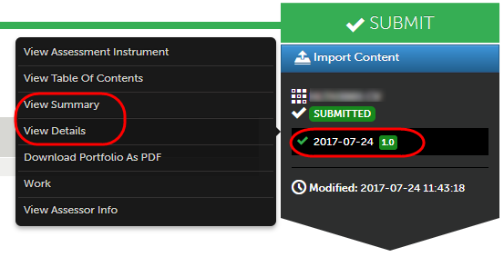  2. Access My Grades in your Blackboard site  - This allows you to view your score only not feedback.  3. My Results in your ePortfolio area  - Menu Work My Results (this section allows you to view all results in your program).
Preview and Download your ePortfolio
How to view your portfolio summary | - Click on the Table of Contents (Book icon).  - Preview to view webpage.  - Download as zip or pdf options.
Change your Portfolio Theme
How to change your theme | - Click on the Table of Contents (Book icon).  - Click on Setup Edit Setup and select a template.  - Click on Save and Close.  - Alternatively, click on Build a Theme to create your own theme.
Upload your Photo
How to upload a photo | - Drop-down on your name.  - Select My Profile  - Drop down on Profile Actions Edit Profile  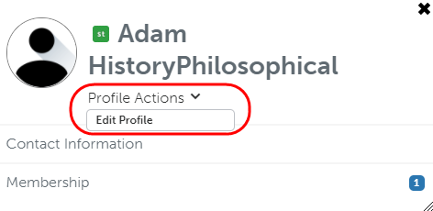  - Choose File and upload your image.  - Click on the Upload and Save Profile button.
Share your Portfolio on LinkedIn
Share your Portfolio on LinkedIn | - Return to the Table of Contents (Book icon).  - In the Sharing section Click on Generate Share URL  - You will be able to share your portfolio on a variety of platforms.  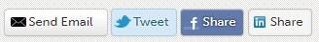
Make sure students have withdrawn
Check to ensure all students have withdrawn their work | - Log into the system using your instructor account.  - Menu Assessment Student Results.  - Put your course code (PHRM1012) in the search field.  - If there are no current submissions listed all students have withdrawn their work successfully.
Wrap Up
Wrap up  (Resources) | - AskUs for technical support.  - Vendor support is available after business hours.

