School of XXXX
In-semester/End-of-semester Examinations, 2024
Course code + course title
This paper is for XXXX Campus students.

Question paper section

Answer all questions in the separate answer booklet provided.

Question 1 (2 marks)
What is the largest city in the southern hemisphere?

Question 2 (3 marks)
Describe three current industrial process used to create hydrogen gas.

Question 3 (10 marks)
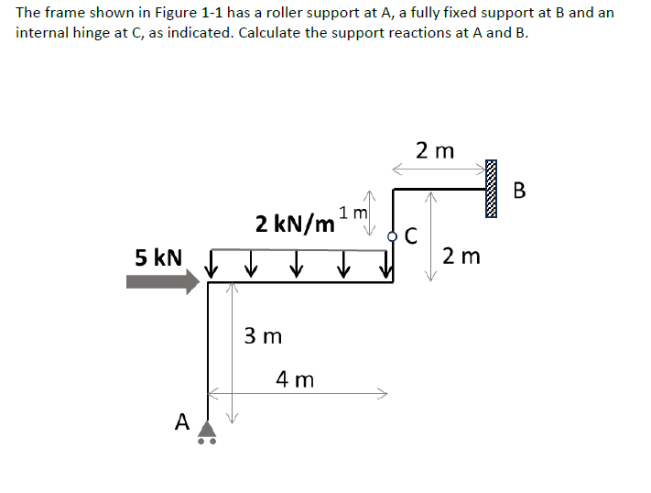

END OF EXAMINATION

